|  |  |  |  |  |  |  |  |  |  |  |  |  |  |  |
| --- | --- | --- | --- | --- | --- | --- | --- | --- | --- | --- | --- | --- | --- | --- |
|  |  |  |  |  |  |  |  |  |  |  |  |  |  |  |
|  |  |  |  |  |  |  |  |  |  |  |  |  |  |  |
|  |  |  |  |  |  |  |  |  |  |  |  |  |  |  |
|  |  |  |  |  |  |  |  |  |  |  |  |  |  |  |
|  |  |  |  |  |  |  |  |  |  |  |  |  |  |  |
|  |  |  |  |  |  |  |  |  |  |  |  |  |  |  |
|  |  |  |  |  |  |  |  |  |  |  |  |  |  |  |
|  |  |  |  |  |  |  |  |  |  |  |  |  |  |  |

|  |  |  |  |  |  |  |  |  |  |  |  |  |  |  |
| --- | --- | --- | --- | --- | --- | --- | --- | --- | --- | --- | --- | --- | --- | --- |
|  |  |  |  |  |  |  |  |  |  |  |  |  |  |  |
|  |  |  |  |  |  |  |  |  |  |  |  |  |  |  |
|  |  |  |  |  |  |  |  |  |  |  |  |  |  |  |
|  |  |  |  |  |  |  |  |  |  |  |  |  |  |  |
|  |  |  |  |  |  |  |  |  |  |  |  |  |  |  |
|  |  |  |  |  |  |  |  |  |  |  |  |  |  |  |
|  |  |  |  |  |  |  |  |  |  |  |  |  |  |  |
|  |  |  |  |  |  |  |  |  |  |  |  |  |  |  |

図１ 図2

|  |  |  |  |  |  |  |  |  |  |  |  |  |  |
| --- | --- | --- | --- | --- | --- | --- | --- | --- | --- | --- | --- | --- | --- |
|  |  |  |  |  |  |  |  |  |  |  |  |  |  |
|  |  |  |  |  |  |  |  |  |  |  |  |  |  |
|  |  |  |  |  |  |  |  |  |  |  |  |  |  |
|  |  |  |  |  |  |  |  |  |  |  |  |  |  |
|  |  |  |  |  |  |  |  |  |  |  |  |  |  |
|  |  |  |  |  |  |  |  |  |  |  |  |  |  |
|  |  |  |  |  |  |  |  |  |  |  |  |  |  |
|  |  |  |  |  |  |  |  |  |  |  |  |  |  |

図１ 図2

|  |  |  |  |  |  |  |  |  |  |  |  |  |  |  |  |  |  |  |  |  |
| --- | --- | --- | --- | --- | --- | --- | --- | --- | --- | --- | --- | --- | --- | --- | --- | --- | --- | --- | --- | --- |
| $$⋮$$ | $$⋮$$ | $$⋮$$ | $$⋮$$ | $$⋰$$ |  |  |  |  | $$⋮$$ | $$⋮$$ | $$⋮$$ | $$⋮$$ | $$⋰$$ |  |  |  |  |  |  |  |
|  |  |  |  | … |  |  |  |  |  |  |  |  | … |  |  |  |  |  |  |  |
|  |  |  |  | … |  |  |  |  |  |  |  |  | … |  |  |  |  |  |  |  |
|  |  |  |  | … |  |  |  |  |  |  |  |  | … |  |  |  |  |  |  |  |
|  |  |  |  | … |  |  |  |  |  |  |  |  | … |  |  |  |  |  |  |  |
|  |  |  |  | … |  |  |  |  |  |  |  |  | … |  |  |  |  |  |  |  |
|  |  |  |  | … |  |  |  |  |  |  |  |  | … |  |  |  |  |  |  |  |

図１ 図2

|  |  |  |  |  |  |  |  |
| --- | --- | --- | --- | --- | --- | --- | --- |
|  |  |  |  |  |  |  |  |
|  |  |  |  |  |  |  |  |
|  |  |  |  |  |  |  |  |
|  |  |  |  |  |  |  |  |
|  |  |  |  |  |  |  |  |
|  |  |  |  |  |  |  |  |
|  |  |  |  |  |  |  |  |
|  |  |  |  |  |  |  |  |

|  |  |  |  |  |  |  |  |
| --- | --- | --- | --- | --- | --- | --- | --- |
|  |  |  |  |  |  |  |  |
|  |  |  |  |  |  |  |  |
|  |  |  |  |  |  |  |  |
|  |  |  |  |  |  |  |  |
| 1/8 | 1/16 | 1/32 | 1/64 |  |  |  |  |
| 1/4 | 1/8 | 1/16 | 1/32 |  |  |  |  |
| 1/2 | 1/4 | 1/8 | 1/16 |  |  |  |  |
| 1 | 1/2 | 1/4 | 1/8 |  |  |  |  |

|  |  |  |  |  |  |  |  |
| --- | --- | --- | --- | --- | --- | --- | --- |
|  |  |  |  |  |  |  |  |
|  |  |  |  |  |  |  |  |
|  |  |  |  |  |  |  |  |
|  |  |  |  |  |  |  |  |
|  |  |  |  |  |  |  |  |
|  |  |  |  |  |  |  |  |
|  |  |  |  |  |  |  |  |
|  |  |  |  |  |  |  |  |

|  |  |  |  |  |  |  |  |
| --- | --- | --- | --- | --- | --- | --- | --- |
|  |  |  |  |  |  |  |  |
|  |  |  |  |  |  |  |  |
|  |  |  |  |  |  |  |  |
|  |  |  |  |  |  |  |  |
|  |  |  |  |  |  |  |  |
|  |  |  |  |  |  |  |  |
|  |  |  |  |  |  |  |  |
|  |  |  |  |  |  |  |  |

|  |  |  |  |  |  |  |  |
| --- | --- | --- | --- | --- | --- | --- | --- |
|  |  |  |  |  |  |  |  |
|  |  |  |  |  |  |  |  |
|  |  |  |  |  |  |  |  |
|  |  |  |  |  |  |  |  |
|  |  |  |  |  |  |  |  |
|  |  |  |  |  |  |  |  |
|  |  |  |  |  |  |  |  |
|  |  |  |  |  |  |  |  |

|  |  |  |  |  |  |  |  |
| --- | --- | --- | --- | --- | --- | --- | --- |
|  |  |  |  |  |  |  |  |
|  |  |  |  |  |  |  |  |
|  |  |  |  |  |  |  |  |
|  |  |  |  |  |  |  |  |
|  |  |  |  |  |  |  |  |
|  |  |  |  |  |  |  |  |
|  |  |  |  |  |  |  |  |
|  |  |  |  |  |  |  |  |

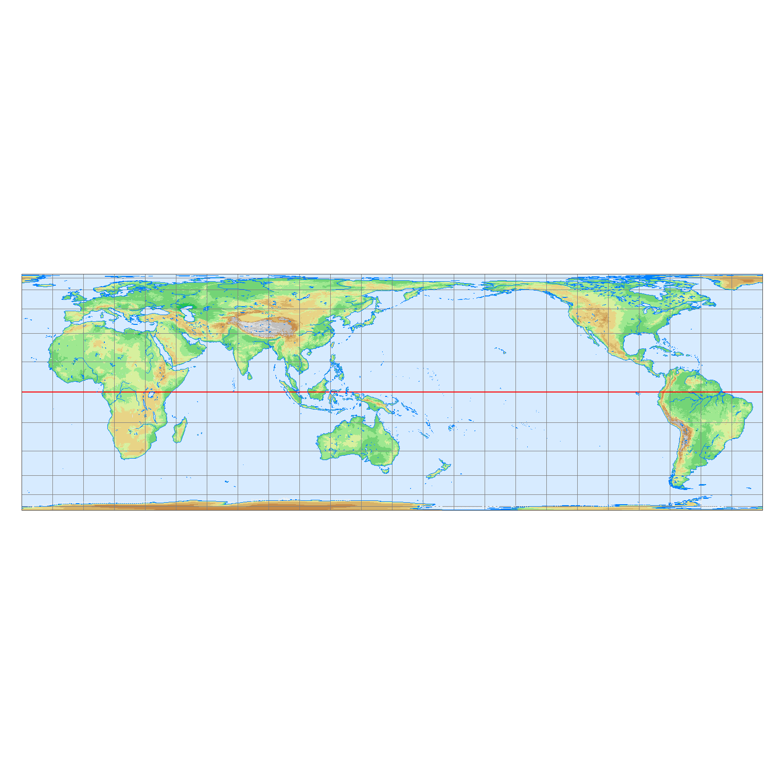

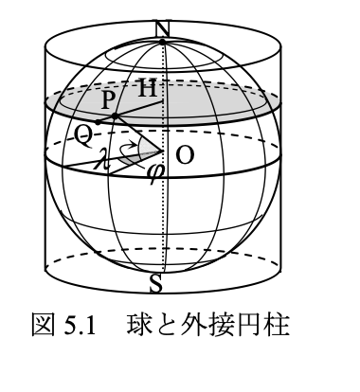

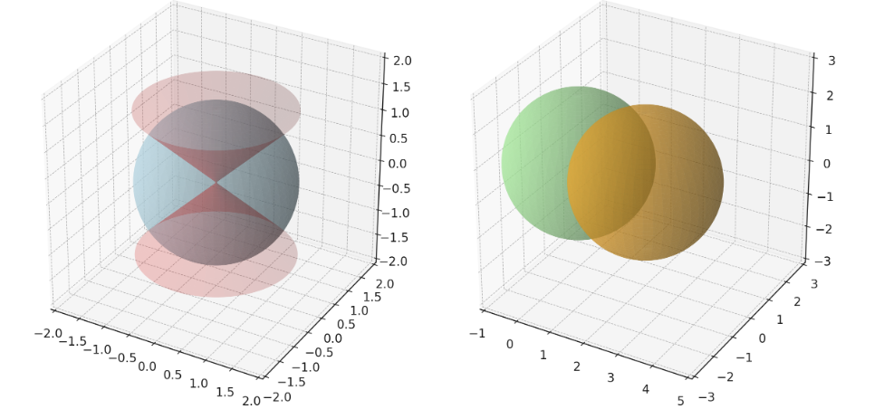

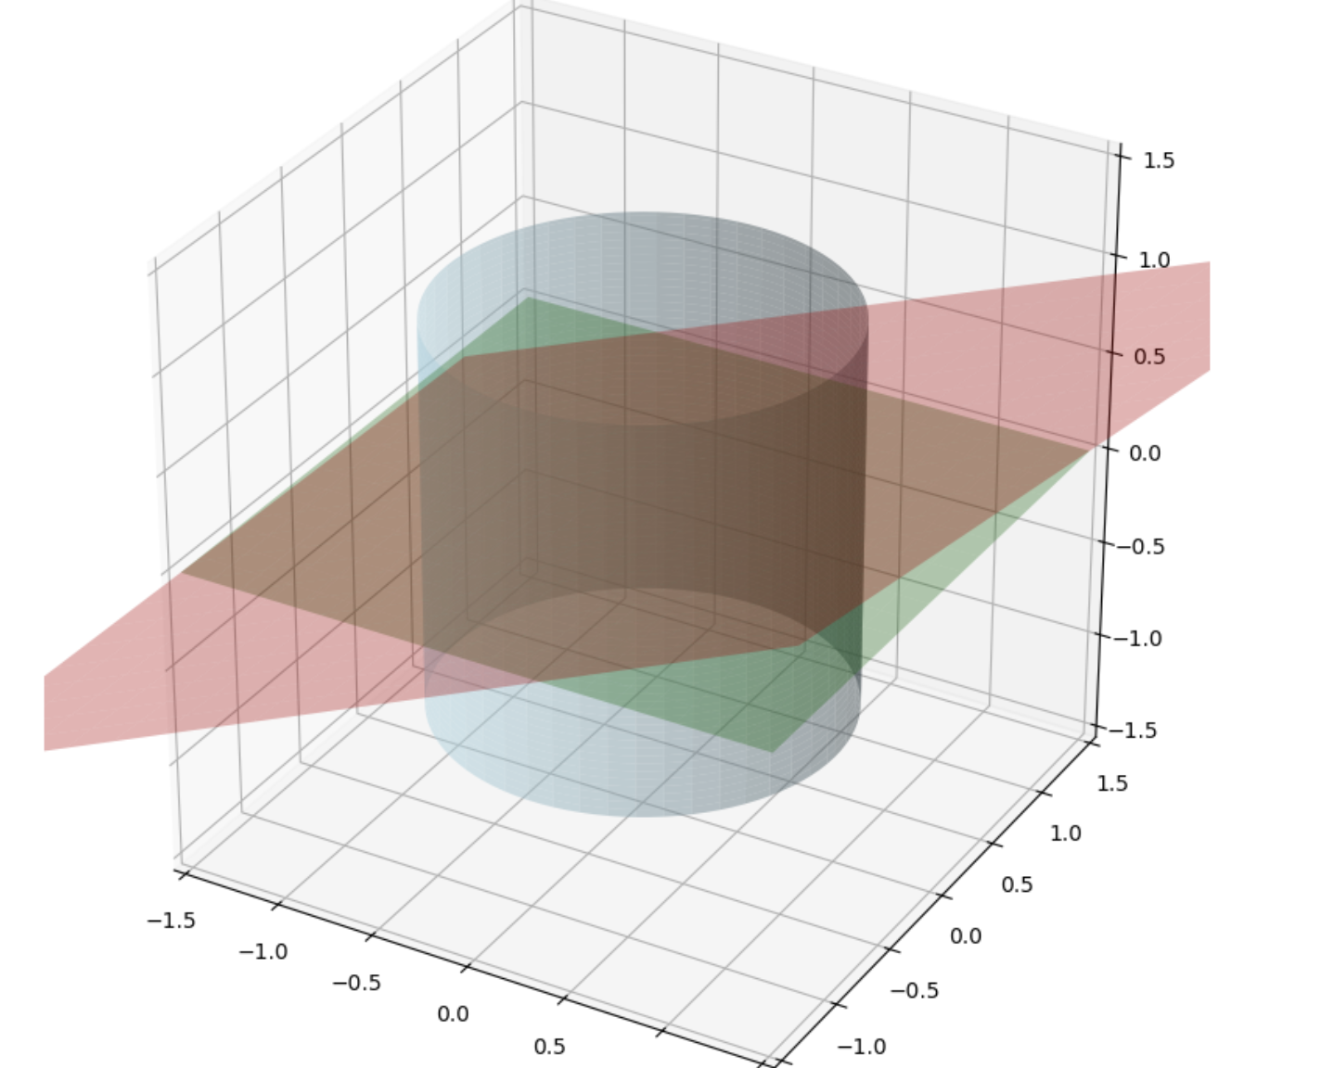

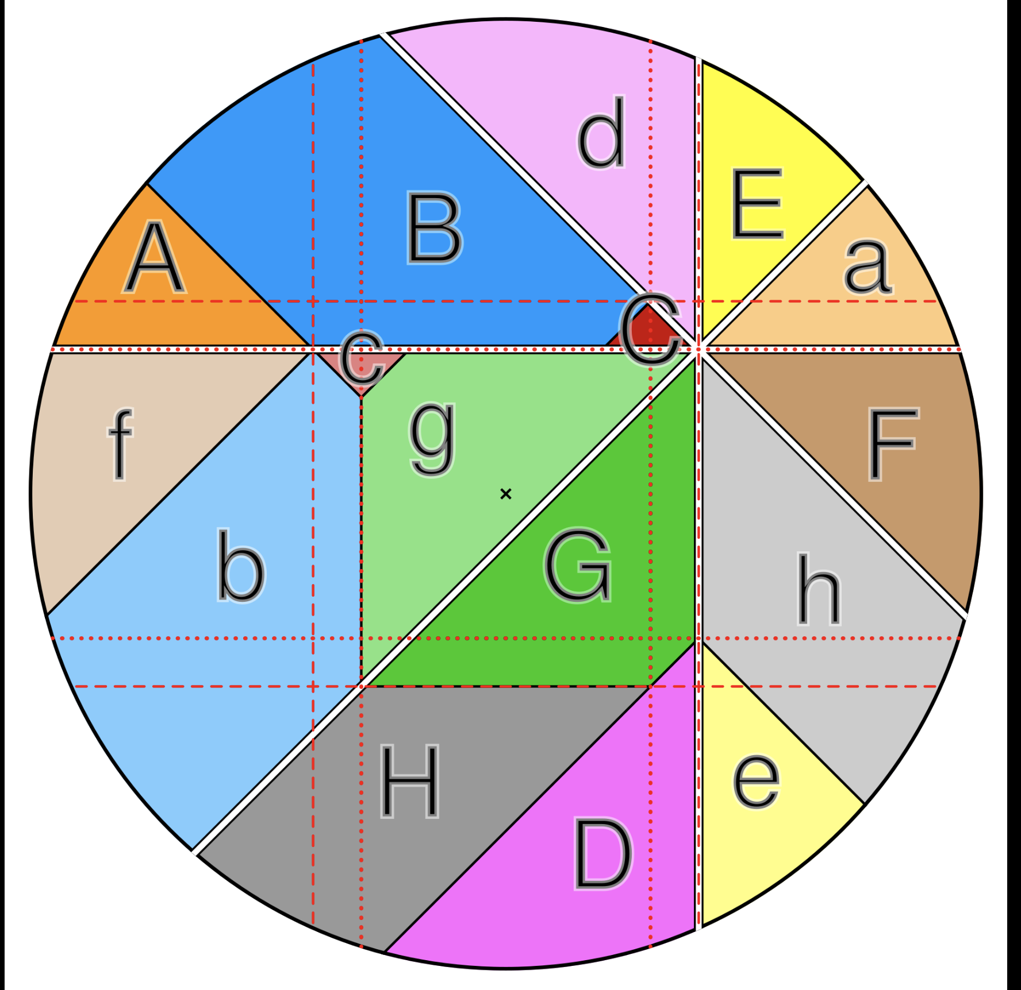

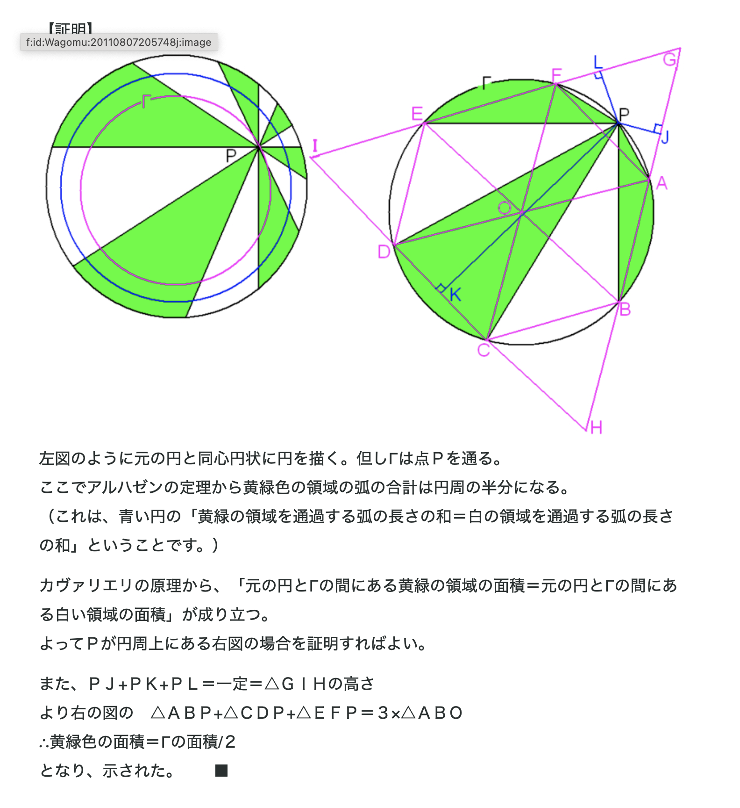

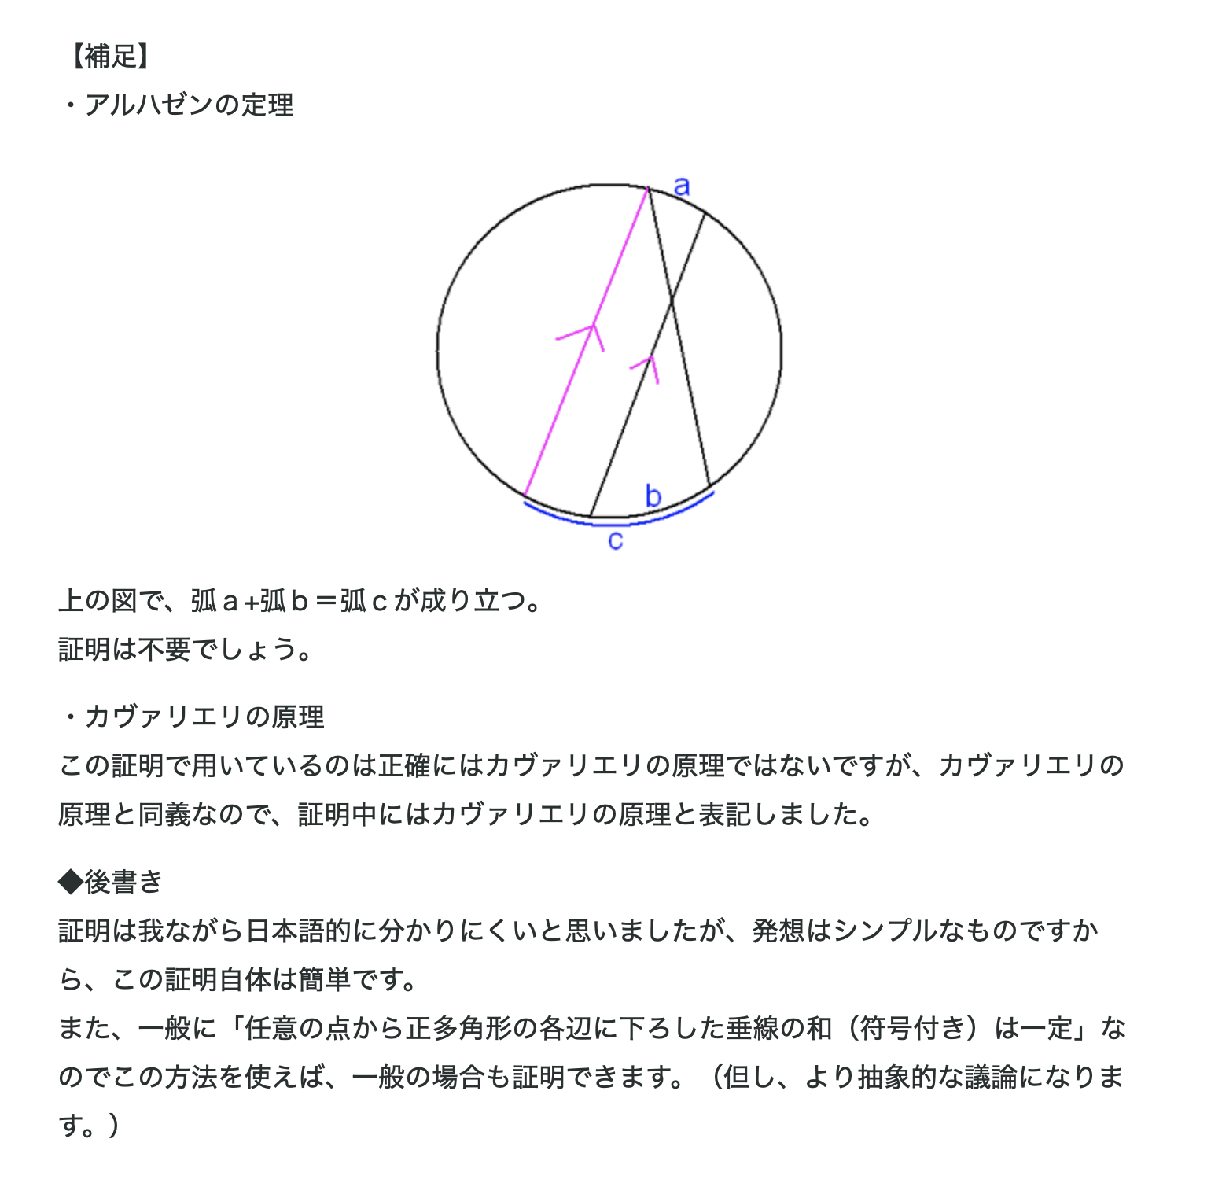

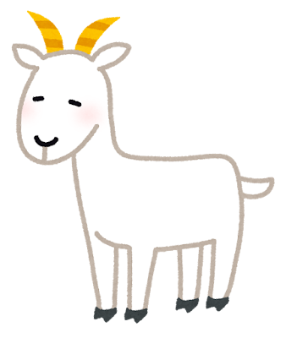





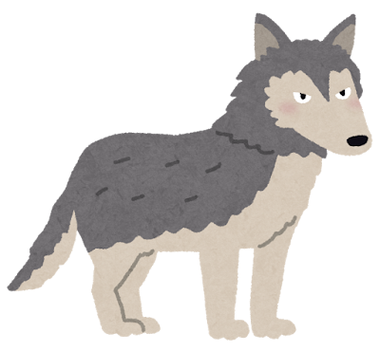





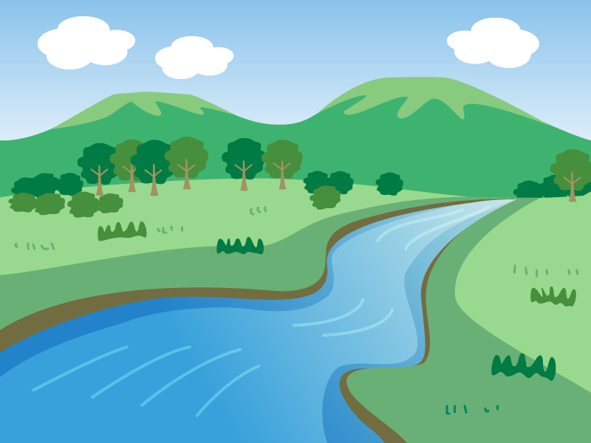

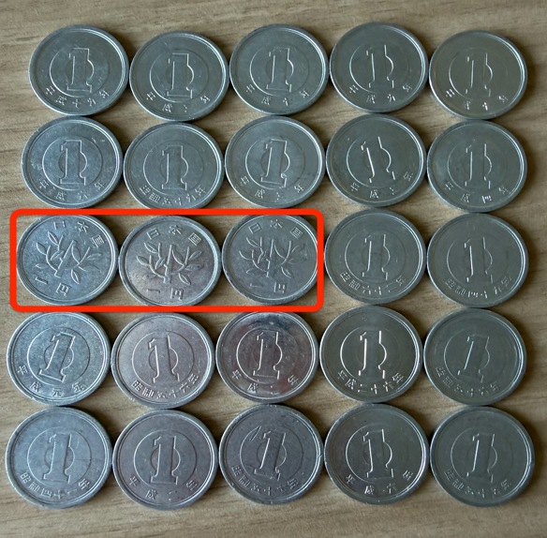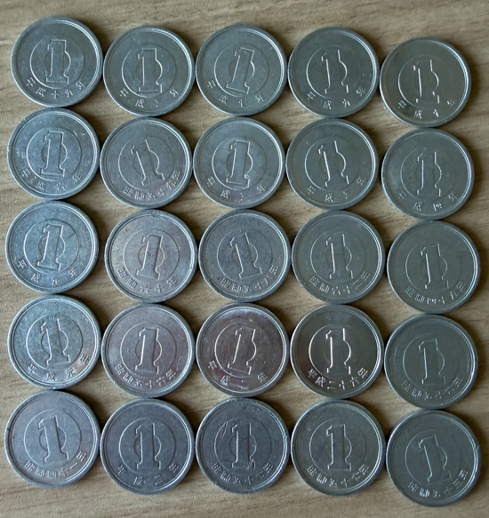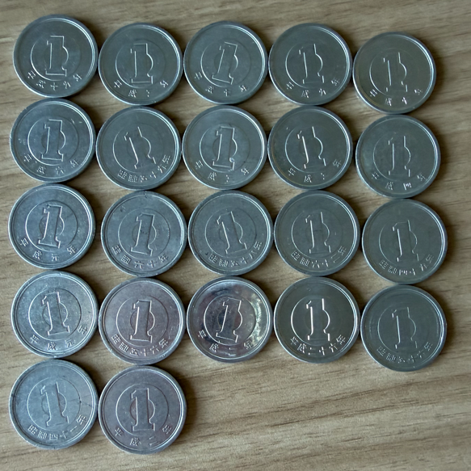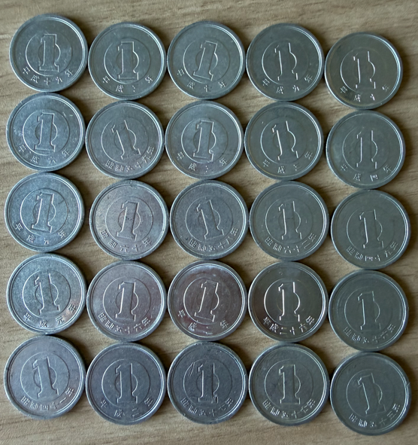

|  |  |  |  |  |
| --- | --- | --- | --- | --- |
| **1** | **2** | **3** | **4** | **5** |
| **6** | **7** | **8** | **9** | **10** |
| **11** | **12** | **13** | **14** | **15** |
| **16** | **17** | **18** | **19** | **20** |
| **21** | **22** | **23** | **24** | **25** |

|  |  |  |  |  |
| --- | --- | --- | --- | --- |
| **1** | **2** | **3** | **4** | **5** |
| **6** | **7** | **8** | **9** | **10** |
| **11** | **12** | **13** | **14** | **15** |
| **16** | **17** | **18** | **19** | **20** |
| **21** | **22** | **23** | **24** | **25** |

|  |  |  |  |  |
| --- | --- | --- | --- | --- |
| **1** | **2** | **3** | **4** | **5** |
| **6** | **7** | **8** | **9** | **10** |
| **11** | **12** | **13** | **14** | **15** |
| **16** | **17** | **18** | **19** | **20** |
| **21** | **22** | **23** | **24** | **25** |

|  |  |  |  |  |
| --- | --- | --- | --- | --- |
| **1** | **2** | **3** | **4** | **5** |
| **6** | **7** | **8** | **9** | **10** |
| **11** | **12** | **13** | **14** | **15** |
| **16** | **17** | **18** | **19** | **20** |
| **21** | **22** | **23** | **24** | **25** |

|  |  |  |  |  |  |  |  |
| --- | --- | --- | --- | --- | --- | --- | --- |
|  |  |  |  |  |  |  |  |
|  |  |  |  |  |  |  |  |
|  |  |  |  |  |  |  |  |
|  |  |  |  |  |  |  |  |
|  |  |  |  |  |  |  |  |
|  |  |  |  |  |  |  |  |
|  |  |  |  |  |  |  |  |
|  |  |  |  |  |  |  |  |
|  |  |  |  |  |  |  |  |
|  |  |  |  |  |  |  |  |